Date: 30/5/22
Email: simon.harley@suffolk.gov.uk

Report for June 2022 to the Parish Councils of
Peninsula Division from Simon Harley (SCC Councillor)

Latest SCC information is available here: https://www.suffolk.gov.uk/coronavirus-covid-19/
For information on supporting Ukrainian refugees in Suffolk, email: refugeesupport@suffolk.gov.uk
Welcome Guidance for Ukrainians arriving in the UK: https://www.gov.uk/government/publications/welcome-a-guide-for-ukrainians-arriving-in-the-uk

- Motion Passed, Further Commitment to Suffolk Rivers
Full Council convened on the 19th May. Our Group proposed a motion for greater commitment towards improving rivers in Suffolk. Currently, all Suffolk rivers have been reported by the Environment Agency to have failed government standards. Increased pollution comes from a rise in sewage discharges, as well as chemicals used in agriculture that run off into waterways.
Our motion committed SCC to improving rivers, investigating what more can be done to enhance waterways, and increase engagement and support with farmers and environmental groups in any future strategies. Our motion was passed unanimously.
Below is a picture of our Group campaigning a successful protest outside Endeavour House:

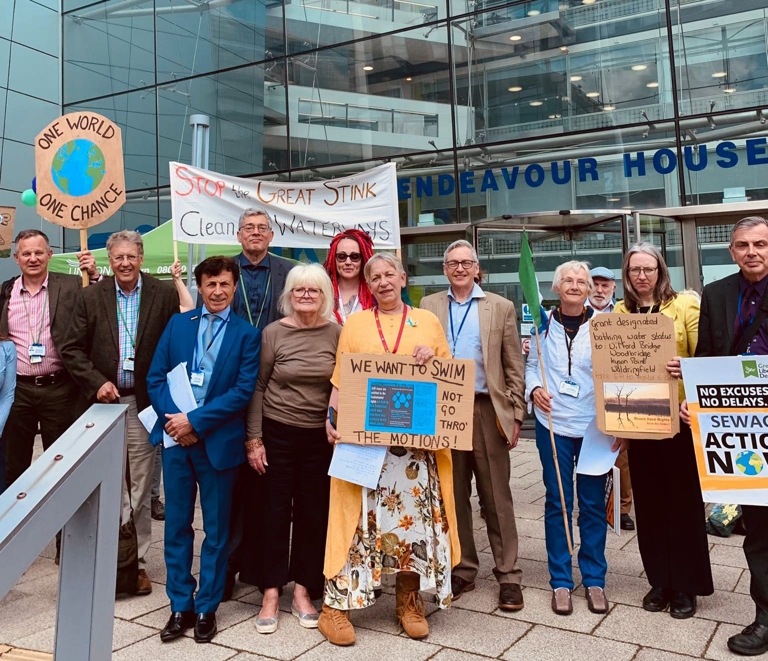

- Current petition for in-house Suffolk Highways maintenance contract
Our Group has started a petition, demanding that SCC produces an in-house bid for the new Suffolk Highways contract. The contract, which will have been held by Kier for 10 years, is up for renewal next year.
Since Kier’s arrival, our Group has seen astronomical prices for the maintenance of Suffolk’s highways. Some of these prices include £5,000 for a pair of dropped kerbs, £7,500 to cut down a single tree, and £10,000 to design (not build) four humps in a road.
Our Group believes an in-house bid from SCC to take back control of Suffolk Highways is needed to get things done. The bid would also provide a necessary benchmark for any competitive bid coming from external companies, making sure Suffolk taxpayers money is not exploited.
We need 3,675 signatures to bring this to debate at the Council. Please sign here (ensure you make you name public, or it won’t count!): https://www.petitions.net/for_suffolk_county_council_to_develop_an_in-house_bid_for_suffolk_highways_maintenance

- Suffolk GLI AGM Meeting
Our Group had our annual group meeting in May. This was a time to discuss all the success we’ve had representing our divisions, as well as assigning the roles and allocations within the Group for 2022/23.
The Group has decided to keep all leadership and spokesperson roles the same. With the pandemic causing disruptions, we felt it was important to keep the roles the same for next year to make sure we are best prepared to be as effective as an opposition as possible.

- National Grid consultation
National Grid have released proposals to increase pylon networks across Suffolk’s countryside, in light of the Government’s strategy to grow the East of England’s offshore electricity generation. Our Group are strongly against the development of more pylon networks impacting Suffolk’s rural landscape and cultural heritage. The proposals are even criticised by Conservative MPs Dan Poulter and James Cartlidge.
Our Group will put pressure on this Council to respond to the consultation, in collaboration with Essex and Norfolk, stressing the significant need for sea-level cables that reduce the community impacts of National Grid’s proposals. Our Group will respond ourselves if the Conservative fail to address our concerns.
If you would like to voice your opinion on the matter, click here (Deadline is the 16th June): https://eastangliagreen.participatr.io/index.php?contentid=13

- Suffolk Show
The Suffolk Show is on between the 31st May-1st June. For more information, visit: https://suffolkshow.co.uk/suffolk-show/

Follow us on:
Twitter - Suffolk Green, Lib Dem & Independent Group (@SuffolkGLI) / Twitter
Instagram (New!) - https://www.instagram.com/suffolkgli_group/
Website - Suffolk Green, Liberal Democrat and Independent Group – The GLI Group at Suffolk County Council (suffolkgli.wordpress.com)

Simon Harley Suffolk County Councillor for Peninsula Division

